MATHEMATICS METHODS

MAWA Semester 1 (Unit1) Examination 2015

Calculator-Assumed

Marking Key

Section Two: Calculator-assumed (90 Marks)

Question 8(a)
Solution
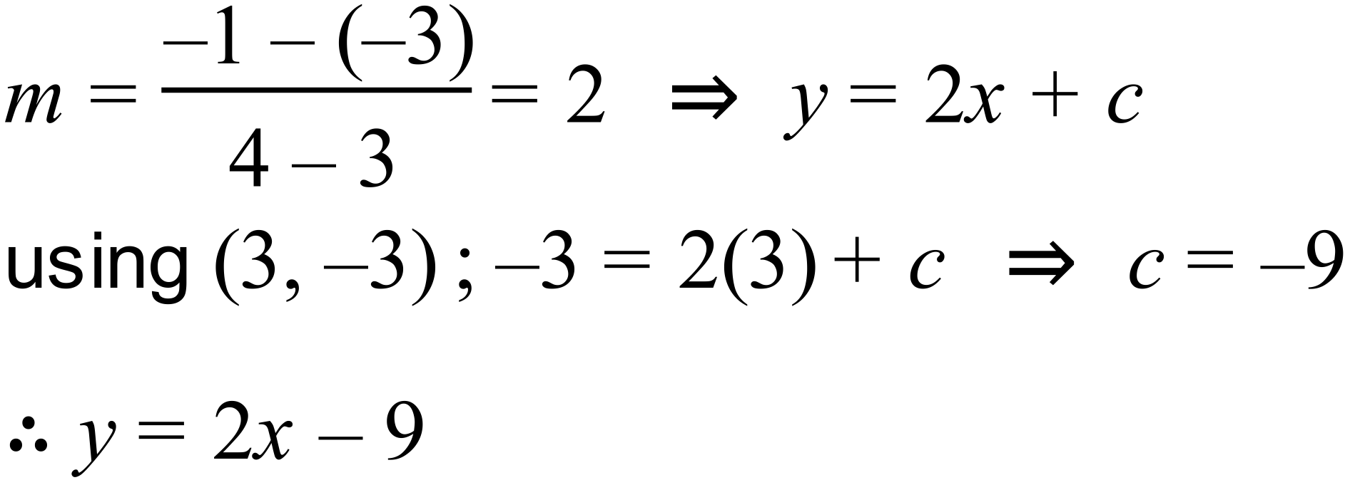
Marking key/mathematical behaviours | Marks
- calculates gradient  - uses a point to calculate c and states equation | 1  1

Question 8(b)
Solution
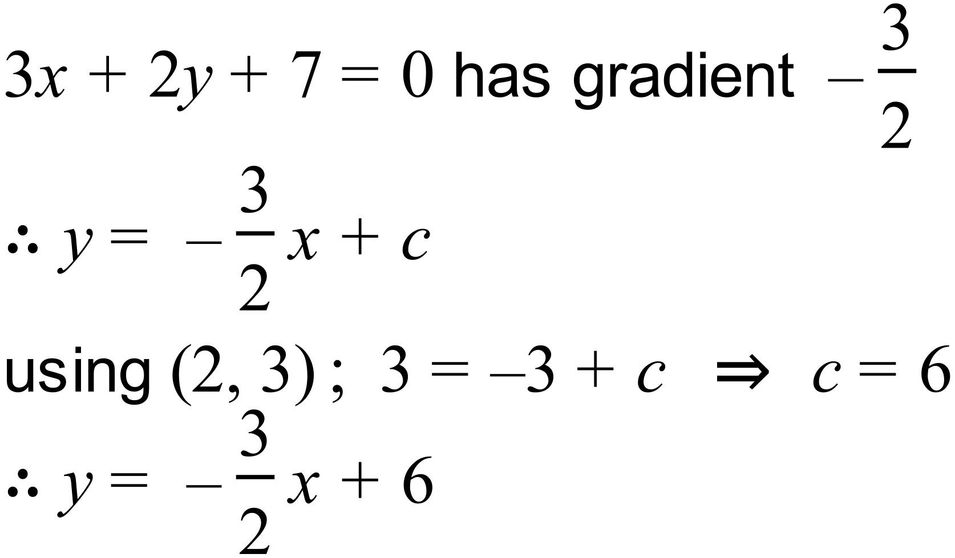

Marking key/mathematical behaviours | Marks
- calculates gradient  - uses the given point to calculate c and states equation | 1  1

Question 8(c)
Solution
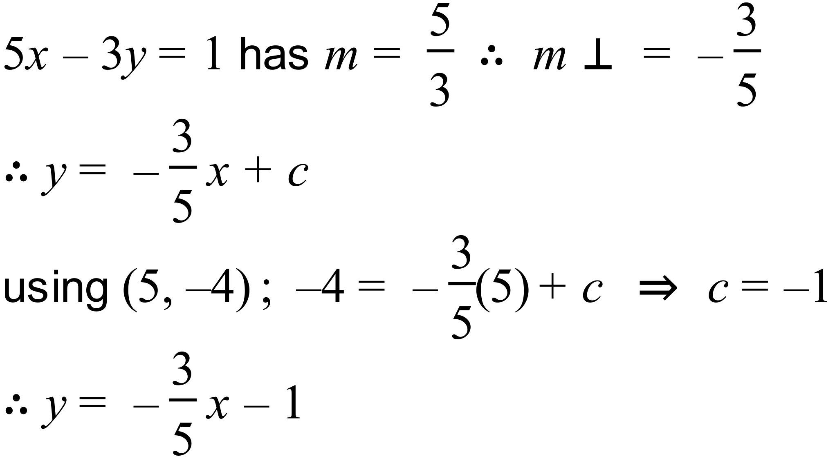

Marking key/mathematical behaviours | Marks
- calculates gradient  - determines perpendicular gradient  - uses the given point to calculate c and states equation | 1  1  1

Question 8(d)
Solution
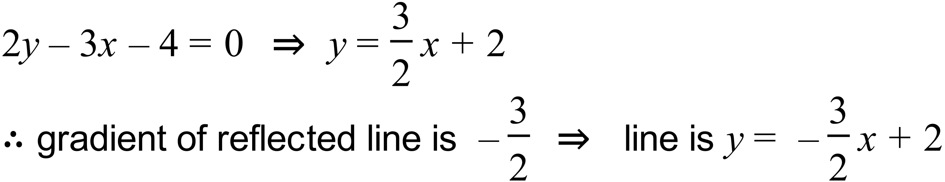

Marking key/mathematical behaviours | Marks
- determines gradient of original line  - determines gradient of reflected line and states equation | 1  1

Question 9(a)
Solution

Marking key/mathematical behaviours | Marks
- reads correctly from the graph  - provides the correct result for  - states correct result for  - correctly states | 1  1  1  1

Question 9(b)
Solution
The events are mutually exclusive, since =0
Marking key/mathematical behaviours | Marks
- states events are M.E.  - provides a valid reason | 1  1

Question 9(c)
Solution
Since we know (given) that the selected person takes at least 5 attempts (=0), this reduces the probability sample space to 0.59
Hence the probability that a selected person takes 5 attempts =
Marking key/mathematical behaviours | Marks
- uses the idea of a reduced sample space  - states the correct response | 1  1

Question 10(a)
Solution
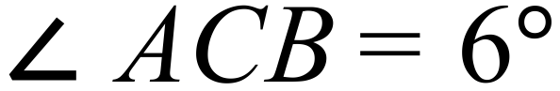

Using the sine rule:

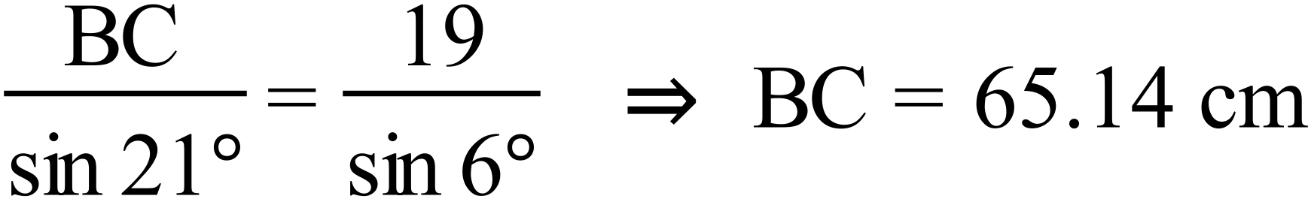
Marking key/mathematical behaviours | Marks
- calculates angle ACB  - uses the sine rule to calculate the length of BC | 1  1

Question 10(b)
Solution
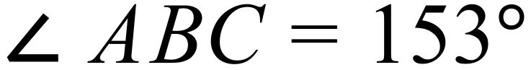
Using the area rule:
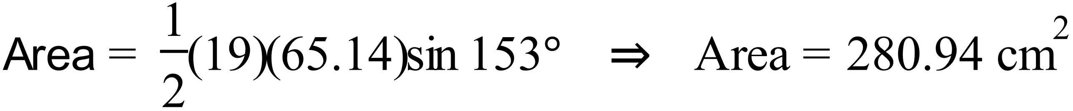
Marking key/mathematical behaviours | Marks
- calculates angle ABC  - uses the area formula to calculate the required area | 1  1

Question 10(c)
Solution

Let the mid-point of BC be D. BD = 32.57 cm
Using the cosine rule:
Marking key/mathematical behaviours | Marks
- calculates the length of BD  - uses the cosine rule to calculate the length of AD | 1  1

Question 11 (a)
one mark ( no need to simplify)
Question 11 (b)

one mark for denominator, one mark for numerator

Question 11 c
one mark for denominator, one mark for numerator

Question 12(a)
Solution
By substitution of into we get . That is, the weight is at the rest (or 0 position).
Marking key/mathematical behaviours | Marks
- Determines that the weight is at the rest position | 1

Question 12(b)
Solution
The period of the weights oscillation is 2 seconds. Hence it goes through the rest position twice every 2 seconds. That is once every second. Because it starts at the rest position and finishes at the rest position, we need to add one. Hence the answer is 6 times.
Alternatively, we note that for every whole number value of .
i.e. when . So 6 times.
Marking key/mathematical behaviours | Marks
- Provides a reasonable explanation as to how arrived at the number of times the weight is at the rest position  - Determines the correct number of times (i.e. 6 times) | 1  1

Question 12(c)
Solution
Negative values of represent the distance that the weight is below the rest position.
The negative represents ‘below the rest position’ the magnitude of the number represents the distance.
Marking key/mathematical behaviours | Marks
- Indicates that the negative represents the distance ‘below’ | 1

Question 12(d)
Solution
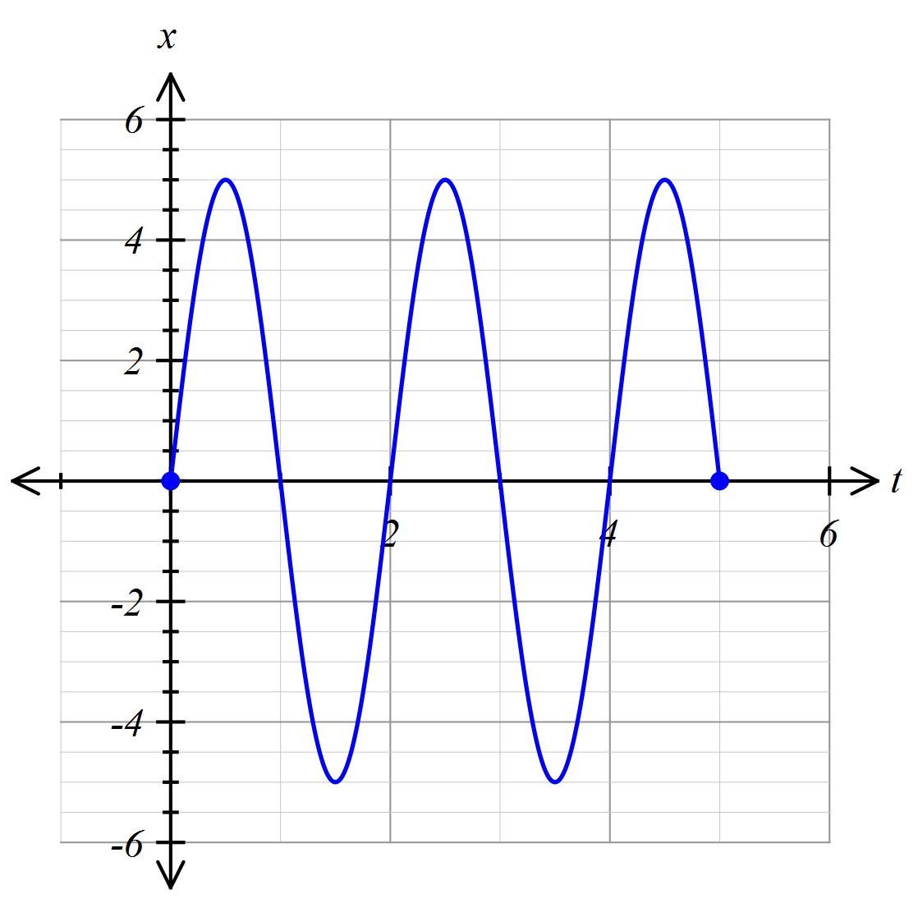
Marking key/mathematical behaviours | Marks
- graph is sinusoidal with correct amplitude and number of cycles  - graph passes through the axis at each of the whole number of seconds in the domain  - graph has smooth TP’s and is acceptably accurate | 1  1  1

Question 12(e)
Solution
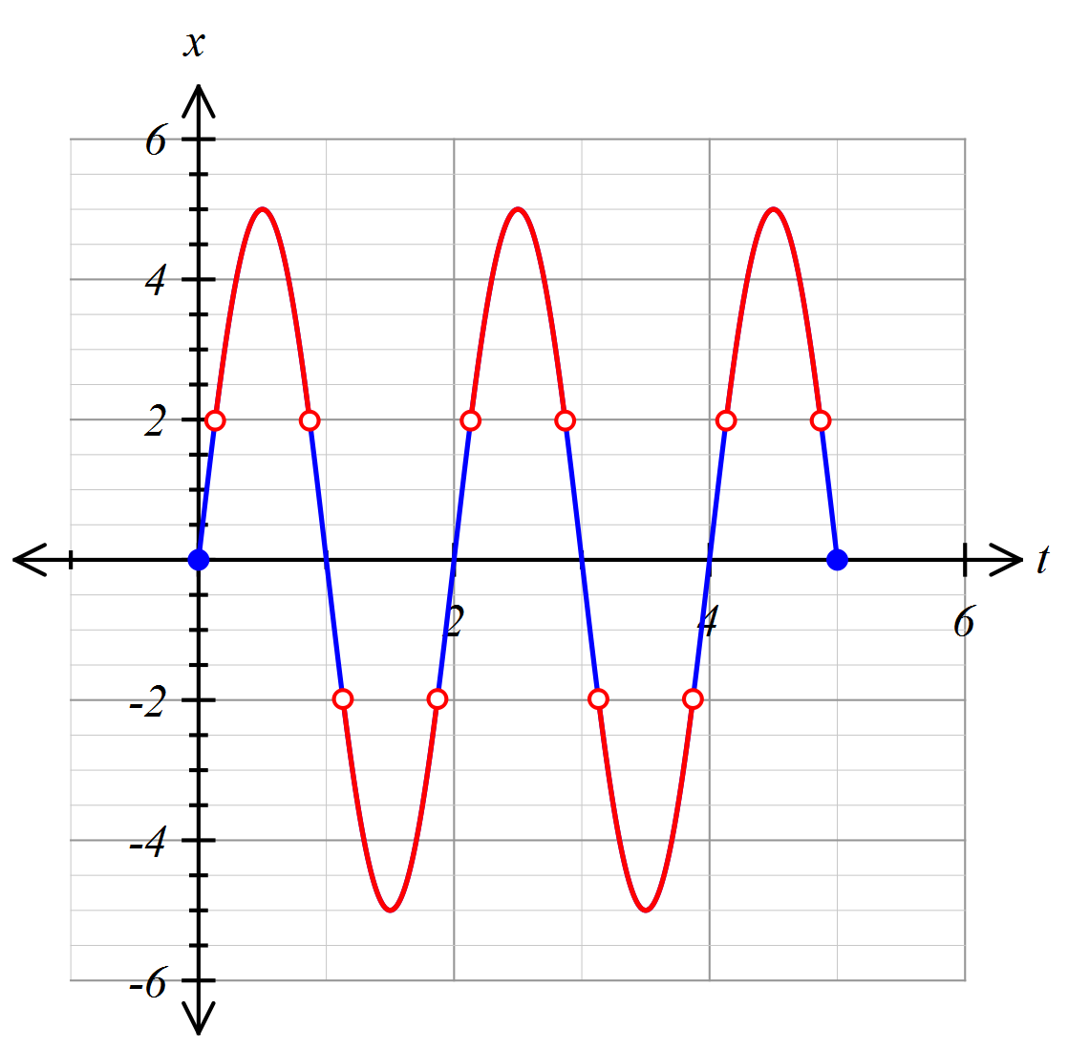
Marking key/mathematical behaviours | Marks
- Indicates (by use of colour or otherwise), the points of the curve where the magnitude of is greater than 2  - Excludes when . | 1  1

Question 12(f)
Solution
From the graph, the values of for which is approximately for the first second of motion. This is approx. 75% of the time. This is repeated during every second of the motion. Hence the fraction requested is approximately .
For a more accurate answer, use a CAS calculator as follows:
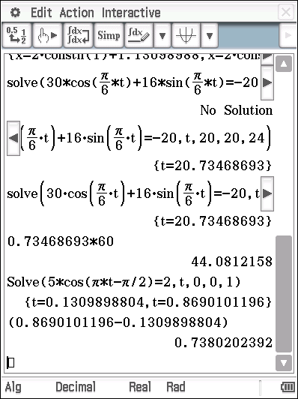
This indicates that the weight is further than 2 cm from the rest position for approximately 73.8% of the time.
Marking key/mathematical behaviours | Marks
- Attempts to estimate the correct fraction of any of the cycles from the graph  - Provides an reasonably accurate estimate (70-80%)  - Use a calculator to refine the result to 73.8% | 1  1  1

Question 13(a)
Solution
Hence domain of = ={0,1,2, …,10}
- Range of ={0,1,2,3,4}
Marking key/mathematical behaviours | Marks
(i)  - states the correct domain of  (ii)  - provides a full listing of the elements of  - states the correct range of | 1  1  1

Question 13(b)
Solution
Hence domain of ={0,1,2,3,4}
- Range of = ={0,1,2, …,10}
Marking key/mathematical behaviours | Marks
(i)  - provides a listing of the elements of  - states the correct domain of  (ii)  - states the correct range of | 1  1  1

Question 13(c)
Solution
is a function, is not as it does not satisfy the vertical line test when graphed (or it has multiple vales for some values i.e. ((2,3) and (2,4) etc.
Marking key/mathematical behaviours | Marks
- indicates that is a function and that is not  - states a valid reason | 1  1

Question 14(a)
Solution
Marking key/mathematical behaviours | Marks
- uses the correct centre  - uses the correct radius | 1  1

Question 14(b)
Solution
Solving simultaneously we get that
Hence the equation is
Marking key/mathematical behaviours | Marks
- uses known points off graph  - determines axis of symmetry  - substitutes two points into a general, appropriate equation of a parabola  - solves for  - states the equation in the required form | 1  1  1  1  1

Question 14(c)
Solution
Marking key/mathematical behaviours | Marks
- determines the discriminant ( of the parabola function equated to 0)  - interprets | 1  1

Question 15 (a)
Solution
substitute 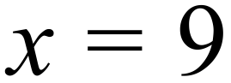 into upper curve and get
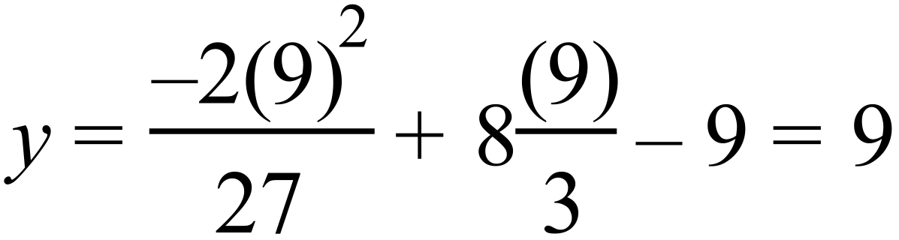
therefore coordinates are (9, 9)
Marking key/mathematical behaviours | Marks
- substitutes x = 9 into upper curve  - states coordinates | 1  1

Question 15 (b)
Solution
using the coordinate (9, 9)
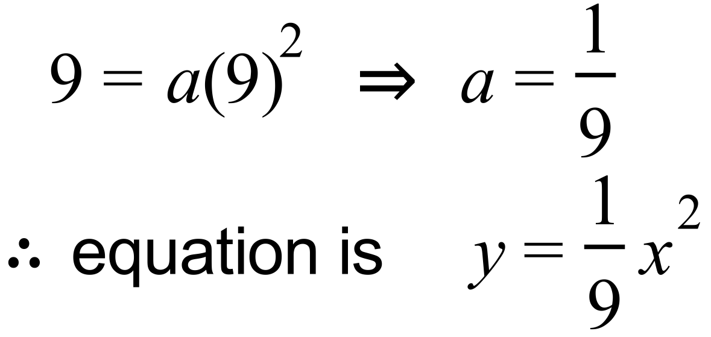
Marking key/mathematical behaviours | Marks
- substitutes x = 9 into lower curve to obtain value of a  - states equation of lower curve | 1  1

Question 15 (c)
Solution
new upper curve: 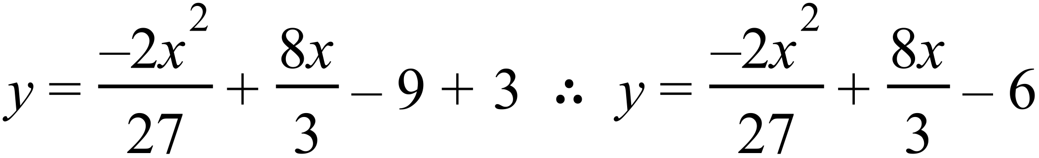
new lower curve: 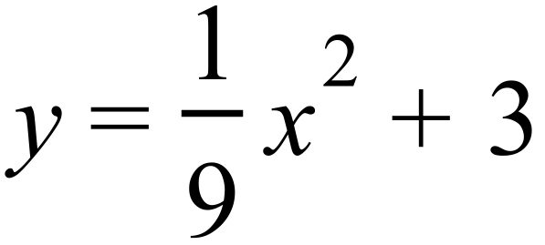
Marking key/mathematical behaviours | Marks
- states equation of new upper curve  - states equation of new lower curve | 1  1

Question 16 (a)
Solution
(i)
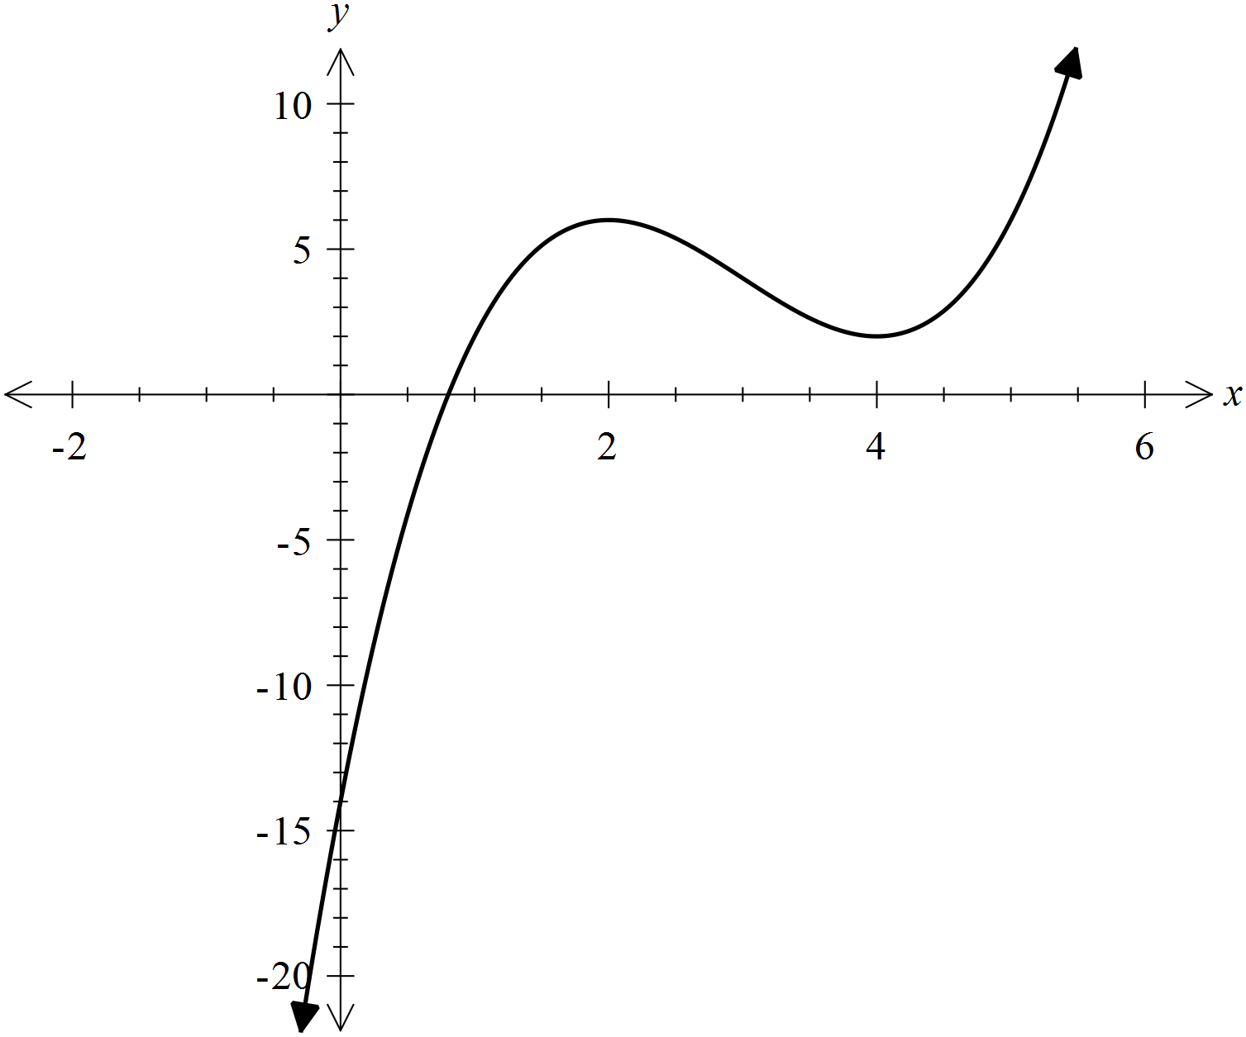

From graph P(x) = 0 only has one real solution

Marking key/mathematical behaviours | Mark
- identifies one solution | 1

(ii)
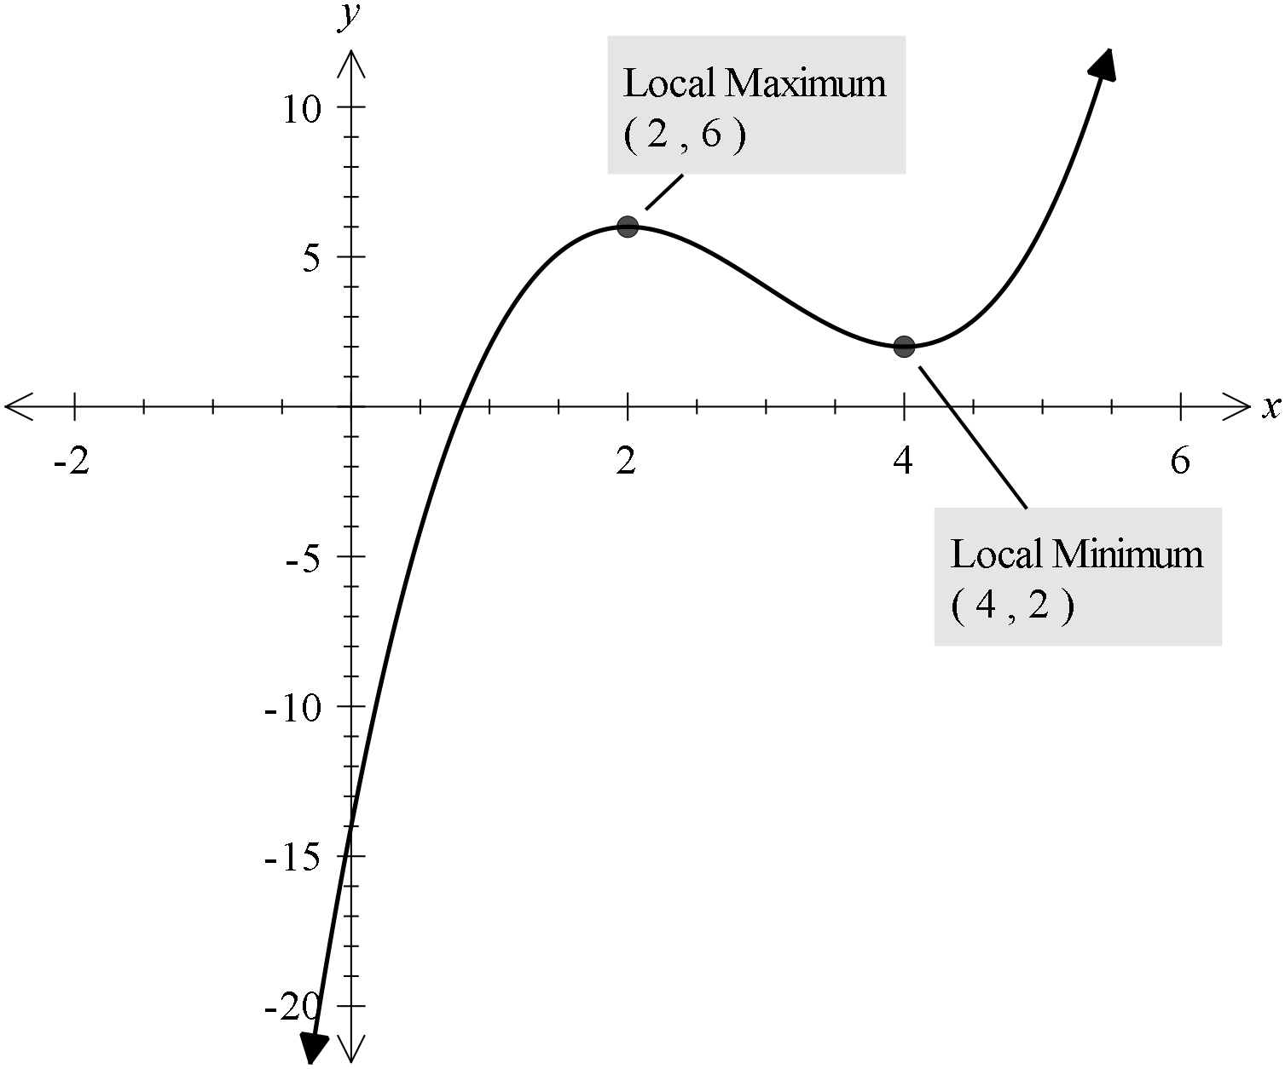

From graph P(x) = k has exactly two solutions when k = 6 or 2

Marking key/mathematical behaviours | Mark
- identifies local max and min points  - identifies P(x) = k has exactly two solutions when k = 6 or 2 | 1  1

Question 16(b)
Solution
dividing by 2
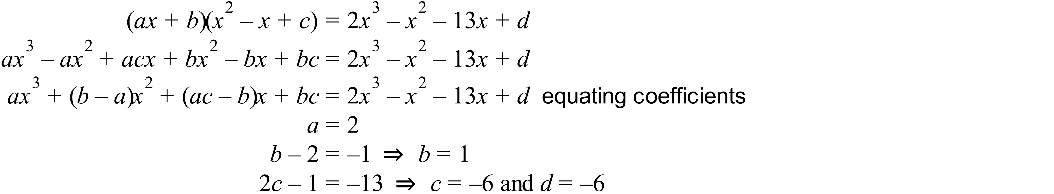Hence
Marking key/mathematical behaviours | Marks
- divides by 2  - expands brackets  - collects like terms  - equates coefficients to solve for a, b, c and d  - factorises expression | 1  1  1  1  1

Question 17(a)
Solution
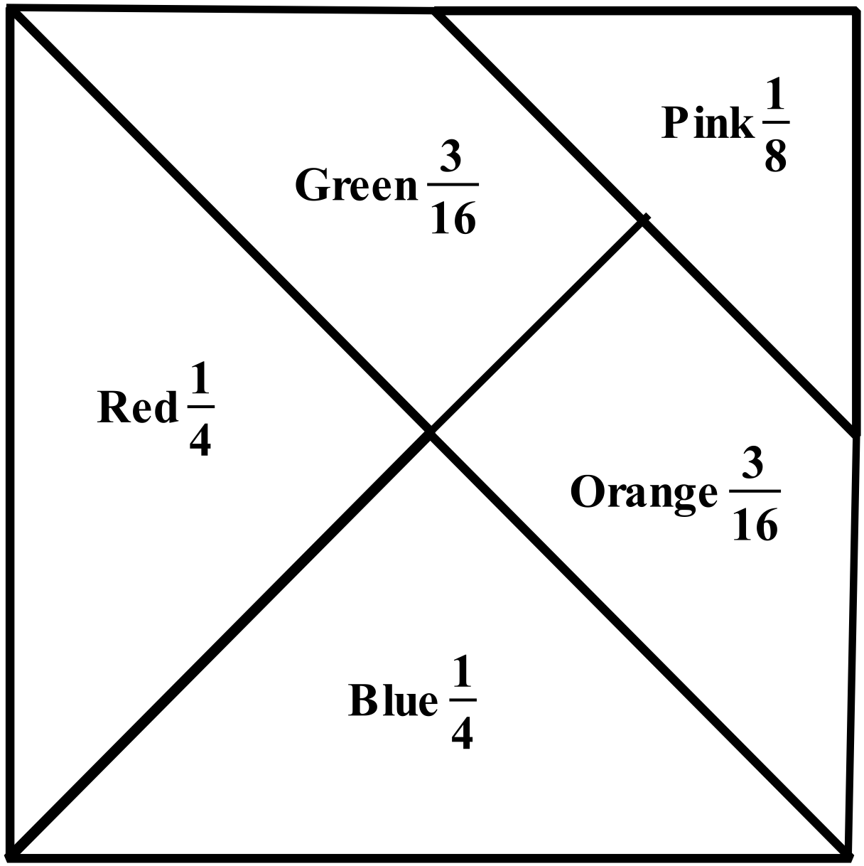
Firstly we determine the proportional areas for each colour (gives the probability sample space). Hence the Probability that the coin lands on Blue is
Marking key/mathematical behaviours | Marks
- represents sample space  - determines the correct probability | 1  1

Question 17(b)
Solution
Marking key/mathematical behaviours | Marks
- identifies that needs to add the proportional areas  - adds the appropriate proportional areas correctly | 1  1

Question 17(c)
Solution
Marking key/mathematical behaviours | Marks
- identifies that two events need to occur simultaneously  - multiplies the appropriate probabilities to get the correct result | 1  1

Question 17(d)
Solution
The events are independent i.e. probability of a tail is not affected by the colour it lands on
Hence, answer is
Marking key/mathematical behaviours | Marks
- identifies that events are independent  - states the correct result | 1  1

Question 17(e)
Solution
Here, it is best to draw a tree diagram to represent what happens
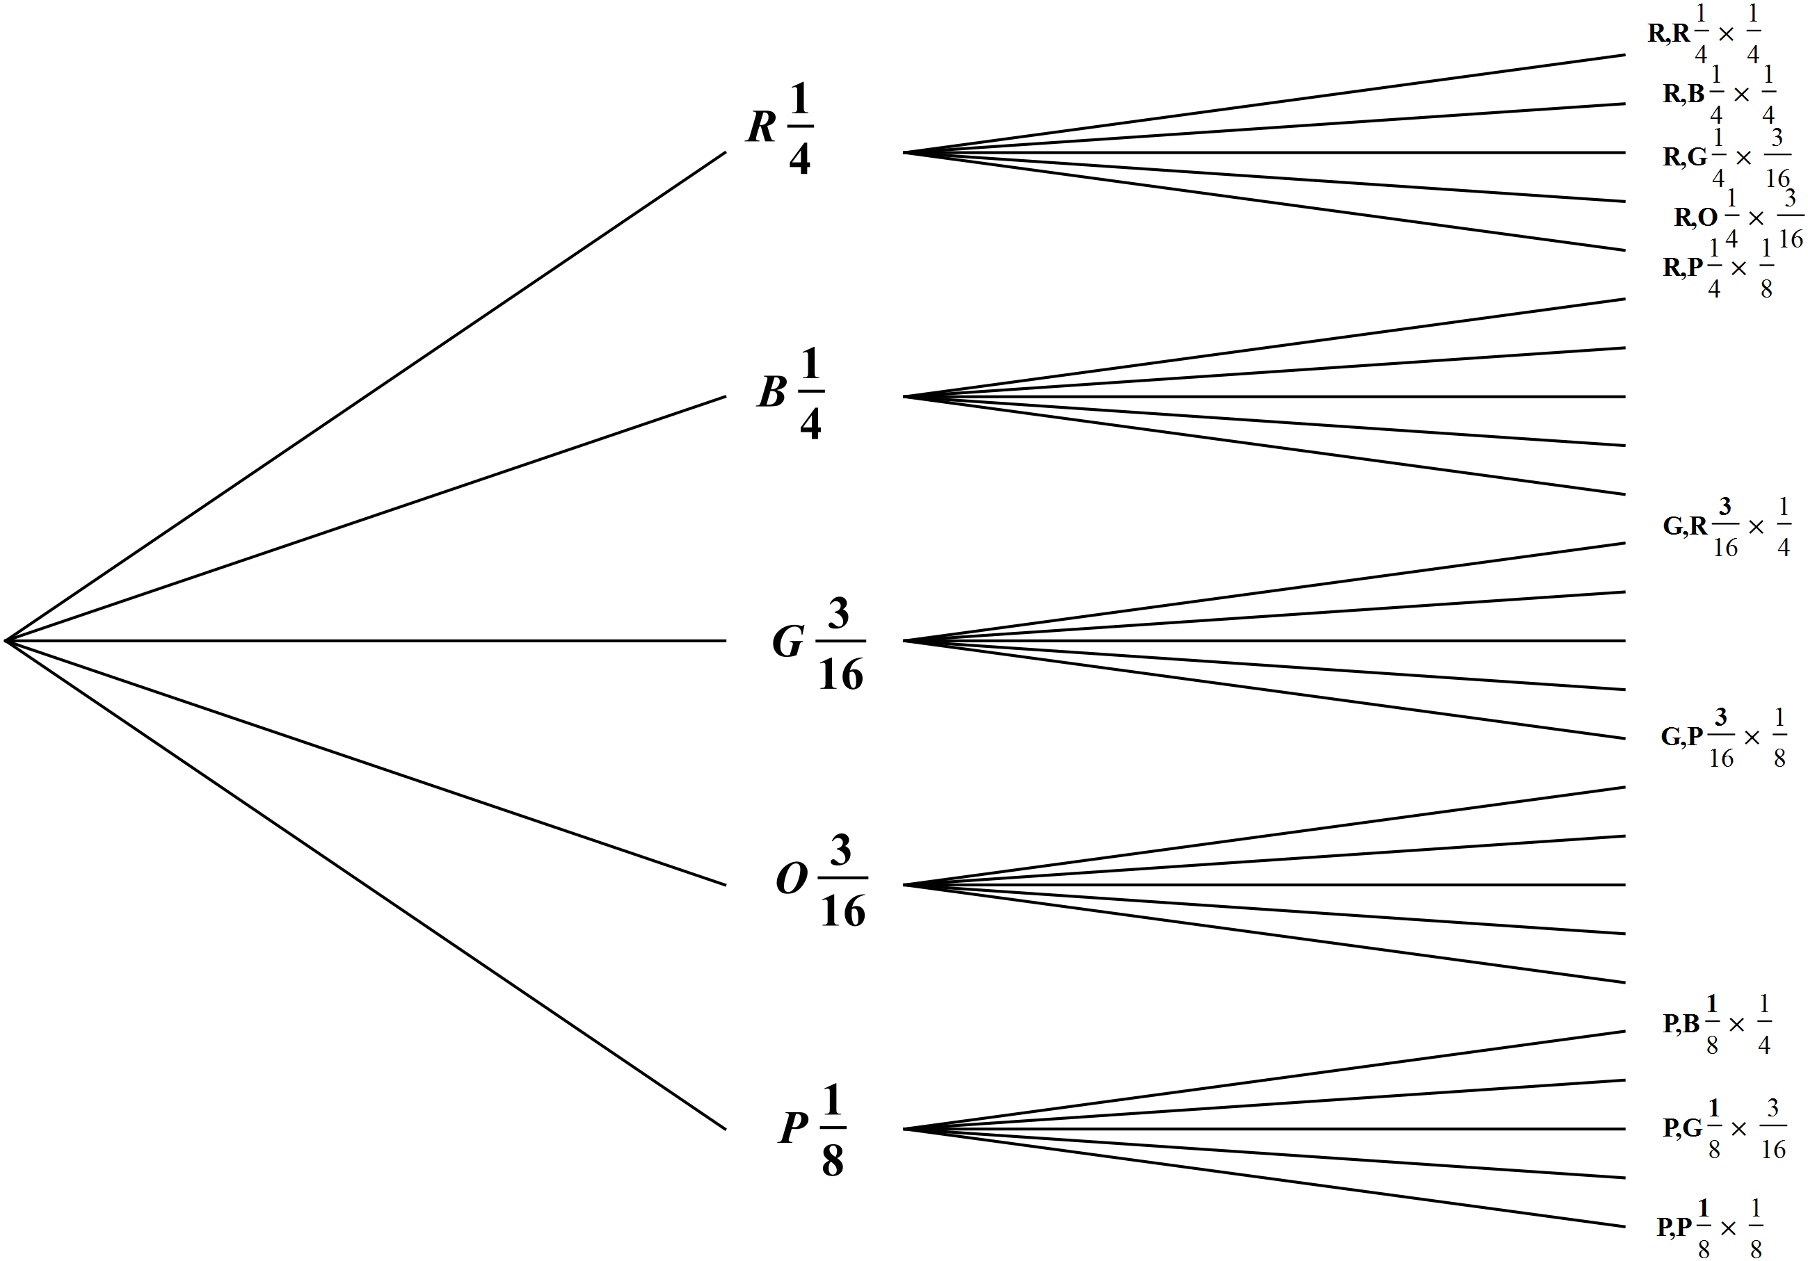

What we want is the probability of:
Blue and Blue or Red and Red or Green and Green or Orange and Orange or Pink and Pink
=
Marking key/mathematical behaviours | Marks
- applies the multiplication principle for simultaneously occurring independent events  - adds the mutually exclusive events  - identifies all the possibilities (by listing or other sample space representation)  - calculates correctly to give the correct result | 1  1  1  1

Question 18(a)
Solution
Marking key/mathematical behaviours | Marks
- Substituting into given identity  - Indicating and simplifying | 1  1

Question 18(b)
Solution
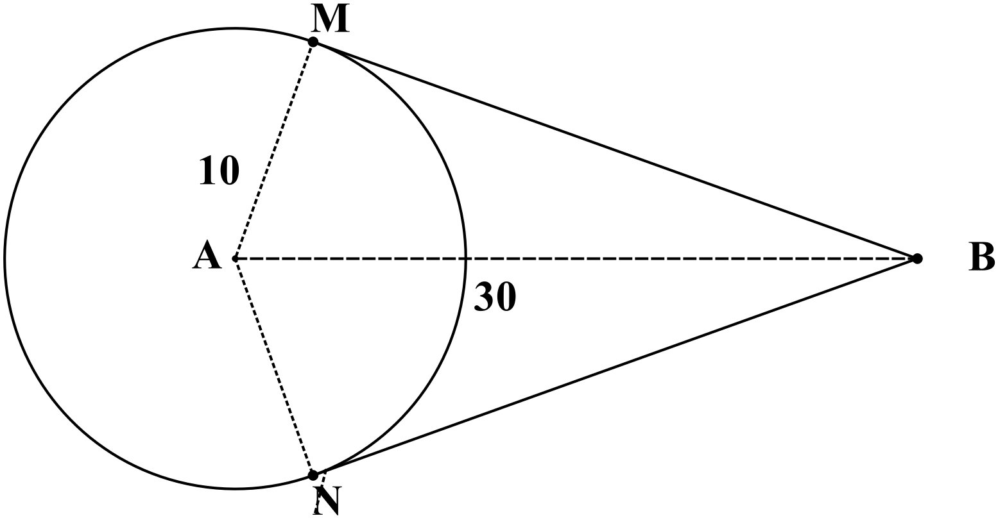
Hence the length of the rope cm
Alternatively, using the geometry app on a CAS
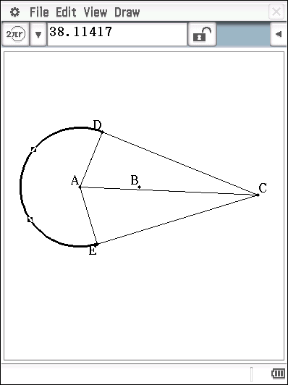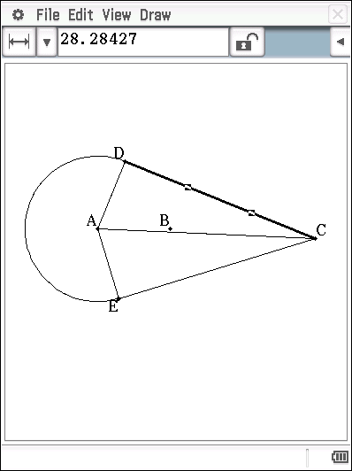

Length of rope = 38.11417+2(28.28427) = 94.68 cm (which is within 1 mm of the above answer, due to rounding)
Marking key/mathematical behaviours | Marks
- Indicates length of AB and shows appropriate central angle on the diagram  - Calculates length of tangents  - Calculates size of central angle  - Calculates appropriate arc length  - Determines correct length of rope (including units)  Or, calculates the length of belt using CAS  - Indicates length of the tangents (implies knowledge of length of AB)  - Indicates length of major arc ()  - Provides the correct length of the rope (including units) | 1  1  1  1  1  or  2  2  1

Acknowledgements

© MAWA, 2015
This examination is Copyright but may be freely used within the school that purchases this licence.
- The items that are contained in this examination are to be used solely in the school for which they are purchased.
- They are not to be shared in any manner with a school which has not purchased their own licence.
- The items and the solutions/marking keys are to be kept confidentially and not copied or made available to anyone who is not a teacher at the school. Teachers may give feedback to students in the form of showing them how the work is marked but students are not to retain a copy of the paper or the marking guide until the agreed release date stipulated in the purchasing agreement/licence.
Published by The Mathematical Association of WA
12 Cobbler Place, MIRRABOOKA 6061

